TECHNICAL TAKE-HOME ASSIGNMENT
Enterprise RAG Attendance Intelligence Microservice
A working MVP to evaluate ingestion, normalization, retrieval, security isolation, and grounded AI responses.
Candidate: Raj Sahu
Assignment objective: Build and demonstrate a working attendance intelligence microservice
Primary evaluation: Architecture discipline, implementation quality, security, and explainability
Submission: Source code, setup instructions, sample data, tests, and a short walkthrough
Assignment outcome The system must accept attendance evidence in multiple formats, convert it into one canonical attendance model, answer questions only from permitted and available data, show citations and confidence, and export the result as JSON, Excel, and PDF.

1. Background and objective
Vardaan Data Sciences builds compliance-oriented enterprise products where data isolation, traceability, deterministic behaviour, and defensible answers are essential. This assignment evaluates whether you can apply those principles to a small but complete AI microservice.
Build a self-contained MVP for an Attendance Intelligence Agent. The agent should accept attendance reports from different sources and formats, normalize the records, make them searchable, answer business questions through a retrieval-augmented workflow, and provide a clear response when the requested information is unavailable or not permitted.

2. Problem statement
An organization receives attendance evidence in inconsistent formats. The evidence may be a flat file, Excel workbook, Word document, PDF, scanned image, or handwritten document. The system must transform these inputs into a common attendance structure and then support questions such as:
- Who was present on a specified date?
- What was the average attendance percentage for a given period?
- Which employee or department had the highest attendance?
- Show the source evidence supporting this answer.
- What should the system say when the supplied data does not contain the answer?
The application should have only a basic front end, if one is provided. The primary evaluation is the backend pipeline, architecture, retrieval quality, security controls, auditability, and demonstration of the full flow.

3. Reference architecture and principles
Use the attached architecture as the reference model. You may use equivalent technologies, but you must explain any substitution in the README and preserve the architectural responsibilities shown below.
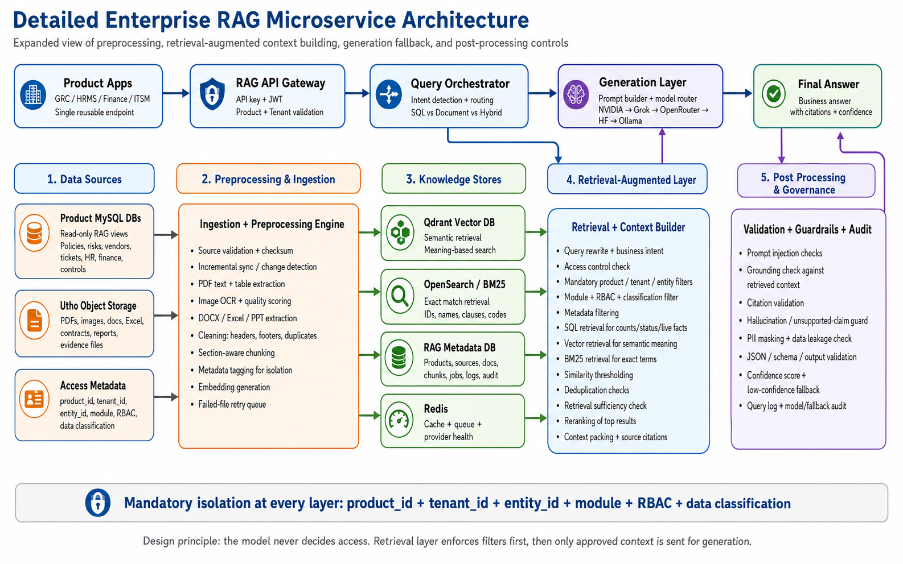
Figure 1. Reference architecture to be followed at responsibility level.
Non-negotiable design rule The model must never decide access. The retrieval layer must enforce product, tenant, entity, module, RBAC, and data-classification filters before context is sent to the generation layer.

3.1 Architectural responsibilities
Layer | Minimum responsibility
API gateway | Expose a reusable endpoint; validate API key/JWT, product, tenant, and request context.
Query orchestration | Classify the request as structured/SQL, document, or hybrid retrieval and route it accordingly.
Ingestion and preprocessing | Validate sources, detect changes, extract text/tables, OCR images, clean content, chunk by section, tag metadata, create embeddings, and retry failed files.
Knowledge stores | Maintain a structured metadata store, semantic vector index, exact/keyword search, and cache/queue/provider-health support.
Retrieval and context building | Rewrite the query, apply access filters, combine structured/vector/keyword retrieval, deduplicate, rerank, check sufficiency, and pack context with citations.
Generation | Use a configurable model provider or router. The prompt must receive only approved context and must not be the access-control layer.
Post-processing and governance | Validate citations and output schema, check grounding and unsupported claims, mask PII, detect prompt injection/data leakage, calculate confidence, provide a low-confidence fallback, and audit the request/model path.

3.2 Mandatory isolation context
Every stored record, chunk, embedding, retrieval request, and audit event must carry or be resolvable to the following context. Demonstrate that the filters are enforced before retrieval results are passed to the LLM:
Required context | Expected behaviour
product_id | A request for one product cannot retrieve another product's data.
tenant_id | Tenant A cannot see, cite, aggregate, or infer Tenant B data.
entity_id | Entity-level access must be enforced where an employee, department, or business unit is the protected entity.
module | Attendance data must not be mixed with unrelated modules.
RBAC and classification | Role and data classification must be checked before retrieval and before export.

4. Functional requirements

4.1 Ingestion and canonical attendance model
Support at least four input types: CSV/flat file, XLSX, DOCX or text-based PDF, and scanned/handwritten image or PDF. You may generate sample data. Do not use real personal attendance records.
Normalize every input into a canonical record model. The following fields are the minimum expected fields; you may add fields where needed for traceability or confidence:
Field | Purpose
attendance_date | Date associated with the attendance event or daily record.
employee_id / employee_name | Stable employee identity and display name.
department / entity_id | Organizational context and protected entity.
status | Present, absent, leave, holiday, work-from-home, or other supported status.
check_in / check_out / total_hours | Time and duration values when available.
source_file / source_page_or_row | Evidence traceability back to the original input.
extraction_confidence | Confidence for OCR or ambiguous extraction; retain the raw value where useful.
product_id / tenant_id / module / classification | Isolation and governance context.

The pipeline should be idempotent: reprocessing the same file must not create duplicate attendance records. Include checksum or equivalent source identity and show how changed files are detected.

4.2 Retrieval and question answering
Provide one query endpoint or service that can answer questions against the normalized attendance data. Use the appropriate retrieval mode for the question: structured queries for counts, averages, totals, and comparisons; document/vector/keyword retrieval for source evidence and narrative fields; and hybrid retrieval when both are required.
Every successful answer must include:
- The answer in a clear business-readable format.
- The tenant, entity, and role context used for the request, without exposing secrets.
- Source citations that identify the file and page, row, or record used.
- A confidence score or confidence band and a short explanation when confidence is low.
- A clear unavailable response when the evidence is insufficient or outside the user's permission.

4.3 Export and basic interface
Provide export of normalized records and/or query results in JSON, Excel, and PDF. A basic web interface is optional but should, if supplied, support upload, processing status, question submission, citations, and export. API documentation or an OpenAPI file is required even if a front end is included.

5. Security, guardrails, and governance requirements
The following controls must be implemented or clearly demonstrated with a working test. Configuration is acceptable where a production integration is not available, but the control path must be visible in code and in the README.
- Authentication and request validation: use API key, JWT, or an equivalent mechanism. Validate product_id, tenant_id, module, role, and entity context at the gateway/service boundary.
- Pre-retrieval access control: enforce all isolation filters before vector, keyword, SQL, or hybrid retrieval. Never retrieve broadly and filter only in the prompt.
- Prompt-injection resistance: treat uploaded content as untrusted data; do not allow instructions inside a document to override system or access rules.
- Grounding and hallucination control: answer only from approved retrieved evidence. If evidence is missing, conflicting, or below threshold, state that the information is unavailable or requires review.
- Citation validation: citations must point to actual source records and must not be fabricated by the model.
- PII and leakage control: mask or avoid returning unnecessary sensitive fields and test that cross-tenant data cannot appear in answers, citations, aggregates, or exports.
- Auditability: log request ID, timestamp, tenant/product/module context, query classification, retrieved source IDs, model/provider, fallback path, confidence, and final outcome. Do not log secrets or raw sensitive content unnecessarily.
- Provider fallback: make the model provider configurable and show a controlled fallback or clear failure when a provider is unavailable.

6. Minimum API and component expectations
The exact endpoint names are your choice. The submission must expose equivalent capabilities to the following minimum contract:
Capability | Minimum input | Minimum output
Ingest | File or object reference plus product/tenant/entity/module context | Job ID, validation result, checksum, status, counts, and failures
Processing status | Job ID | Stage status, retry/error details, normalized record count, and completion state
Query | Question plus authenticated context and optional date/entity filters | Answer, citations, confidence, retrieval mode, and audit/request ID
Export | Dataset or query reference plus format | JSON, XLSX, or PDF export restricted by the same access context
Health/diagnostics | Optional dependency/provider checks | Service, database, queue, cache, search, vector, and model-provider status

7. Acceptance criteria and mandatory test scenarios
The evaluator should be able to run the project from the README and verify the following scenarios. Automated tests are preferred; manual demonstration is acceptable only for the UI or OCR portions.
Test area | Pass condition
Mixed-format ingestion | At least four different input types are processed into the canonical schema.
Extraction traceability | Each normalized record can be traced to a source file and page, row, or record.
OCR/handwriting handling | The system records OCR confidence or review status and does not silently present uncertain values as facts.
Idempotency | Re-uploading the same file does not duplicate records; changed files are detected or versioned.
Structured answers | Attendance counts, averages, and highest/lowest comparisons use structured data and return correct results.
Evidence answers | Narrative/source questions return grounded citations that exist in the source metadata.
Unavailable answer | A question outside the supplied evidence produces a controlled unavailable/insufficient-evidence response.
Tenant isolation | A query under Tenant A cannot return or cite Tenant B records, including through aggregates or exports.
RBAC/entity isolation | A role or entity without access receives a denial or filtered result before generation.
Prompt injection | Malicious instructions embedded in an uploaded file cannot change the system policy or reveal restricted data.
PII/data leakage | Sensitive fields are masked or restricted according to the demonstrated classification policy.
Provider failure | The service records model/provider failure and uses a safe fallback or returns a clear controlled error.
Export consistency | JSON, XLSX, and PDF outputs contain the same permitted records and preserve source references.

8. Expected submission package
- Source code in a repository or compressed project folder with a clean, reproducible setup.
- README covering architecture, technology choices, environment variables, local setup, run commands, API examples, and known limitations.
- Docker Compose or an equivalent one-command local startup path where practical.
- Generated sample input files covering all required formats, plus the canonical attendance schema and expected results.
- Automated unit/integration/security tests and a short test summary showing the mandatory scenarios.
- Architecture diagram mapping the implementation to the reference layers and showing where isolation is enforced.
- API documentation or OpenAPI specification.
- A short walkthrough recording or live demonstration showing ingestion, a successful answer with citations, an unavailable answer, a blocked cross-tenant query, and export.

9. Evaluation rubric
Area | Weight | What will be assessed
Architecture and isolation | 25% | Clear separation of gateway, ingestion, stores, retrieval, generation, and post-processing; mandatory filters enforced before retrieval.
Ingestion and normalization | 20% | Mixed-format handling, canonical model, OCR approach, traceability, idempotency, and error handling.
Retrieval and answer quality | 20% | Correct structured/hybrid routing, semantic and exact search, context selection, citations, and useful answers.
Security and governance | 20% | Authentication, tenant/RBAC/entity isolation, prompt-injection resistance, PII controls, audit logs, confidence, and fallback.
Engineering quality | 10% | Code quality, tests, documentation, reproducibility, diagnostics, and maintainability.
Demonstration and usability | 5% | Clear walkthrough, basic interface/API usability, and ability to explain design decisions and trade-offs.

10. Candidate guidance and boundaries
- Equivalent technologies are permitted. Do not copy the exact technology names from the diagram unless they are appropriate for your implementation; explain substitutions.
- A polished front end is not required. A reliable API, clear responses, tests, and a reproducible local demo are more important.
- Paid APIs or production cloud infrastructure are not required. Use local, free-tier, mocked, or configurable providers where necessary, while keeping the provider boundary clear.
- Use synthetic data only. Do not commit credentials, API keys, personal attendance data, or sensitive documents.
- The assignment is evaluated as an MVP. Clearly identify what is implemented, what is simulated, and what would be strengthened for production.
Submission checklist Before submitting, confirm that a reviewer can start the service, ingest the sample files, ask at least three questions, verify citations and confidence, test an unavailable question, test a blocked cross-tenant request, and export permitted results in all three formats.

